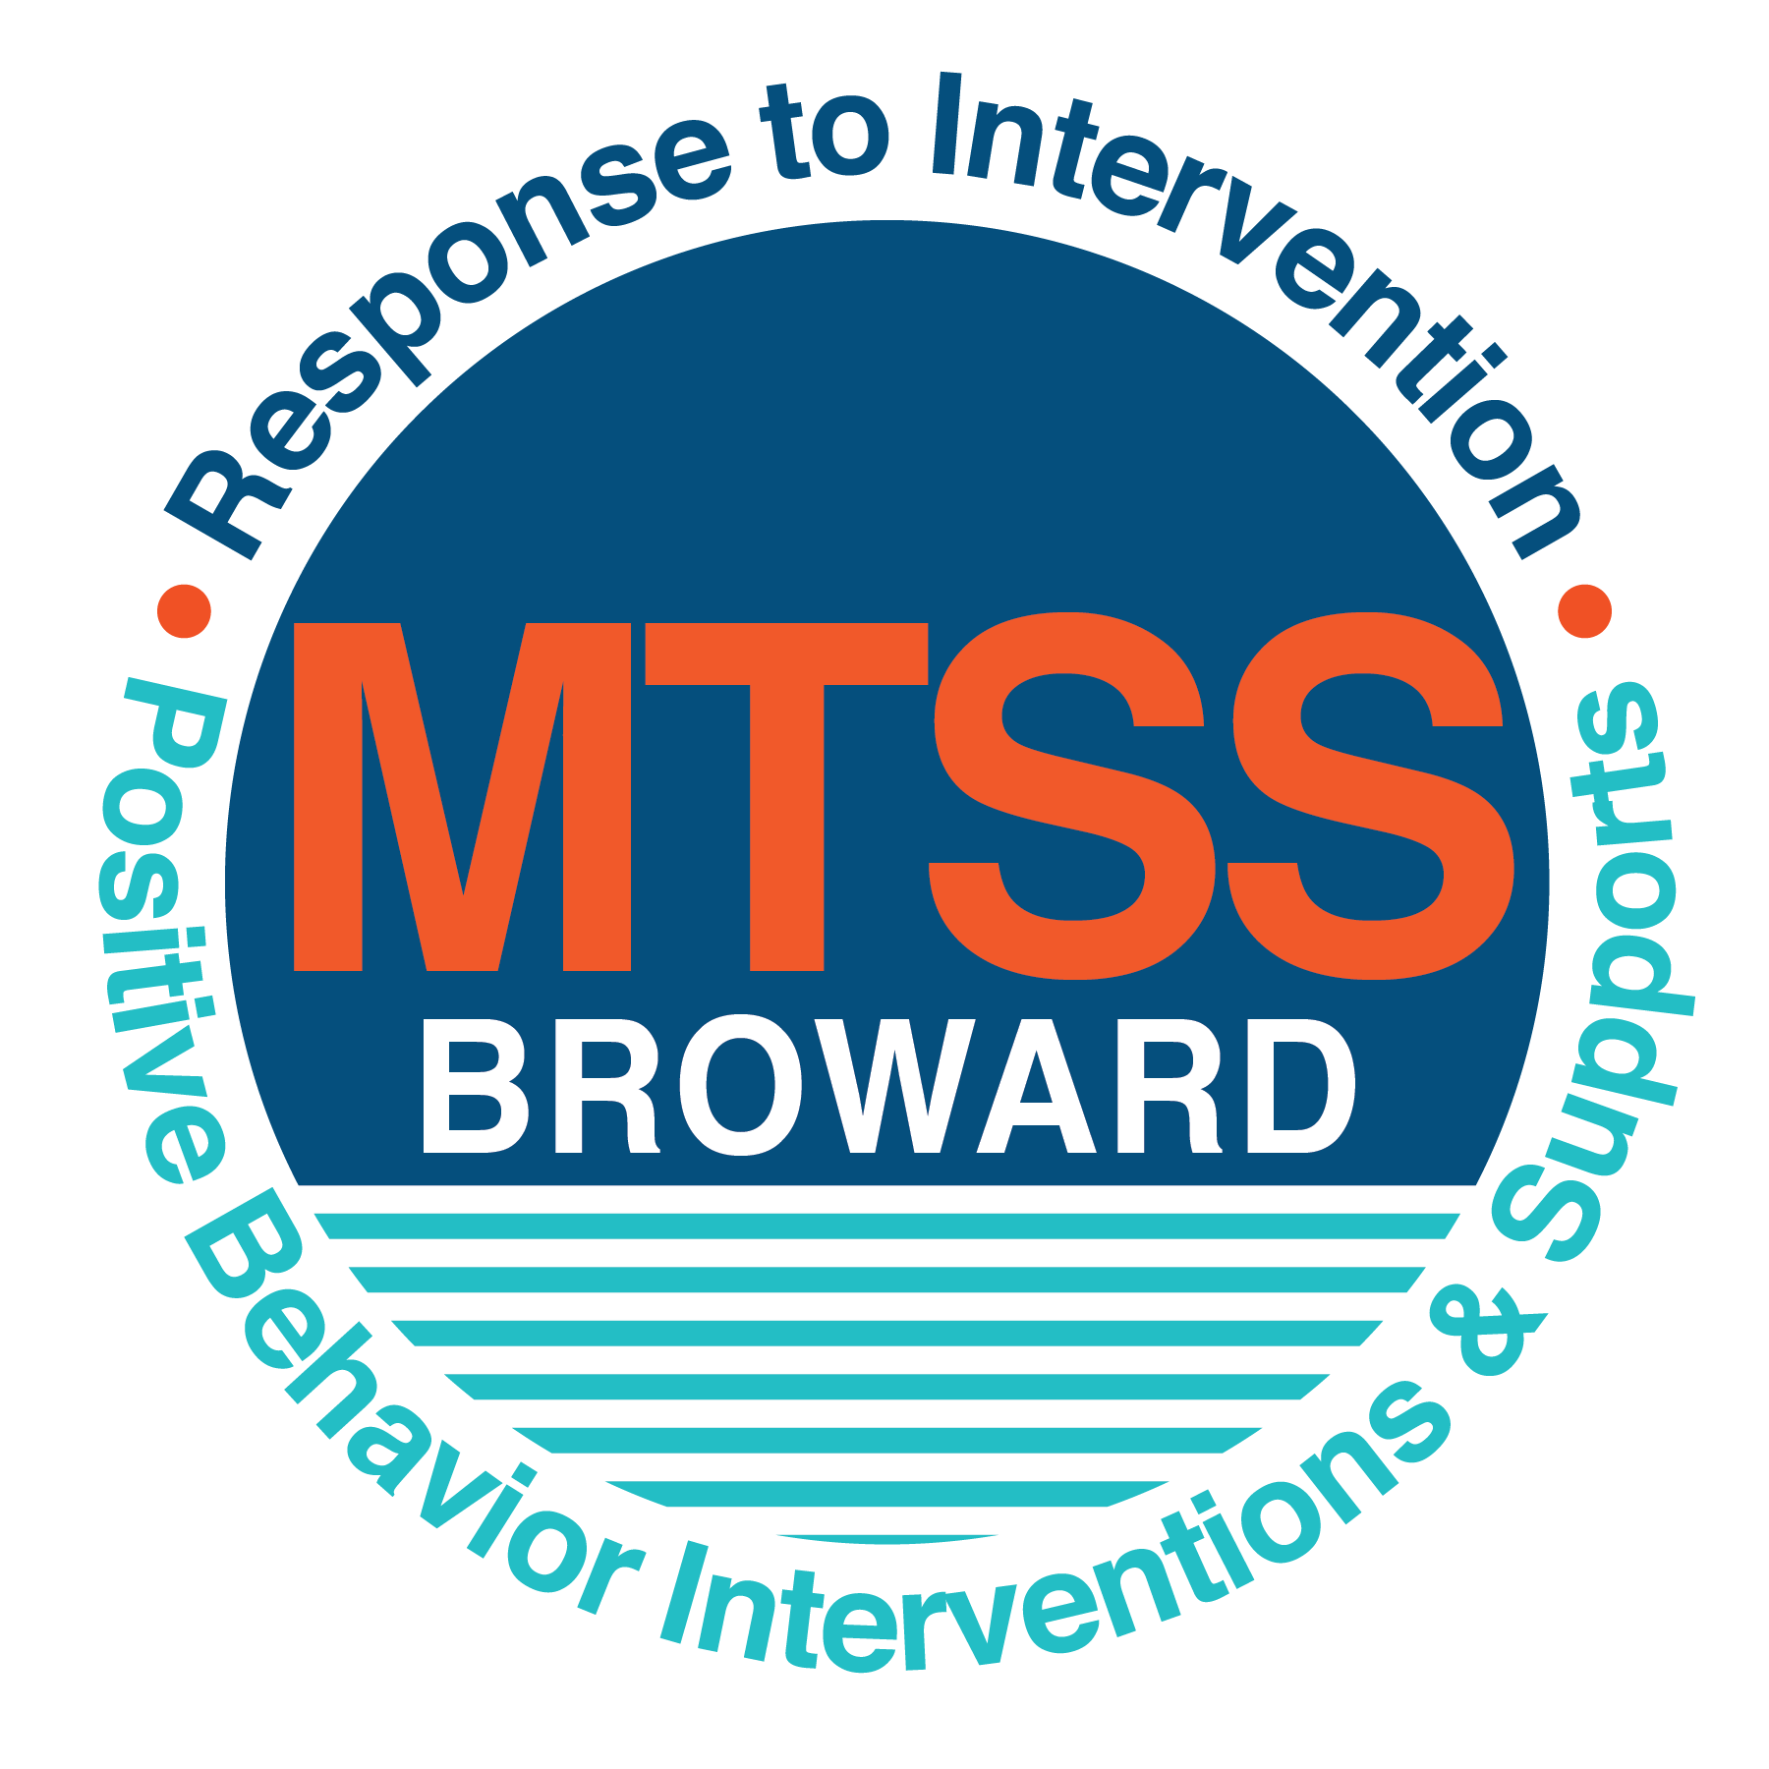

**School-wide Positive Behavior Plan (SPBP)**

Broward County Public Schools

SY 2022 - 2023

|  |  |
| --- | --- |
| **School Name:** | **Nova Eisenhower Elementary** |
| **School Number:** | **1271** |

|  |
| --- |
| **CRITICAL ELEMENT # 1: Active Team with Administrative Participation** |

**1A.** PBIS Team Members

|  |  |  |  |
| --- | --- | --- | --- |
| **First and Last Name** | **Title** | **First and Last Name** | **Title** |
| Angine Tyghter | 1. Administrator | Diane Haggerty | 6. SAC Chair/ Math Resource Teacher |
| Deborah Prochaska | 2. BTU Representative | Michelle Skinner | 7. 2nd Grade Teacher |
| Ashley Diamond | 3. SPBP Point of Contact | Tammy Cheney | 8. 1st Grade Teacher |
| Natlie Mondesir | 4. Parent/Community Representative | Natalie Stuart | 9. 3rd Grade Teacher |
| Darlene Adams | 5. Equity Liaison | Dana Paz | 10. 5th Grade Teacher |

**1B**. Schedule of quarterly PBIS data meetings.

Meeting Objectives:

1. Progress monitor the action steps indicated in Critical Element #9.

2. Collect & analyze fidelity of staff implementation data in #10A using the 4 Step Problem Solving Process.

3. Collect & analyze student outcome data in #10B using the 4 Step Problem Solving Process.

|  |  |  |  |  |
| --- | --- | --- | --- | --- |
| **Quarter** | **PBIS Data Meeting Dates** | **PBIS Data Meeting Times** |  | **Faculty and Staff Data Communication/Presentation Dates** |
| 1st | 8/9/2022 | 8:30 a.m. |  | 8/11/2022 |
| *2nd* | 10/21/2022 | 8:30 a.m. |  | 11/8/2022 |
| 3rd | 1/13/2023 | 8:30 a.m. |  | 2/1/2023 |
| 4th | 4/20/2023 | 8:30 a.m. |  | 5/10/2023 |

|  |
| --- |
| **CRITICAL ELEMENT # 2: Faculty & Stakeholder Commitment:** |

**2A**. PBIS team communication/presentation of new SPBP to staff and stakeholders

|  |  |
| --- | --- |
| **Action Steps:** | **Dates** |
| Present the 2022-23 SPBP to staff *(prior to May 27, 2022)* | 5/20/2022 |
| Hold a *faculty* vote on the new SPBP *(prior to May 27, 2022)* | 5/24/2022 |
| Provide training to faculty and staff *(prior to May 27, 2022)* | 5/25/2022 |
| Present the 2022-23 SPBP to family and community *(prior to September 30, 2022)* | 9/19/2022 |

|  |
| --- |
| **CRITICAL ELEMENT # 3: School-wide Expectations** |

**3A.** Top five behavior incidents data ***from the 2021-2022 school year*** as listed in BASIS 3.0.

|  |  |
| --- | --- |
| **Top 5 Behavior Incidents** | **# Incidents** |
| 1. Disobedience/Insubordination | 36 |
| 2. Fight/Minor Altercation | 27 |
| 3. Mistreatment of Peers | 20 |
| 4. Unruly/Disruptive Behavior | 18 |
| 5. Defiance of Authority/Habitual | 7 |

**3B.** School-wide expectations are 3 – 5 positive characteristics *(not behaviors)* that counteract the top school-wide misbehaviors in section 3A. ALL people on campus are expected to model these expectations.

|  |
| --- |
| **School-wide Expectations** |
| 1. Demonstrate self-control |
| 2. Demonstrate tolerance of others |
| 3. Remember a positive attitude is everything |
| 4. Demonstrate respect and responsibility to self and others |
| 5. Strive for Success |

**3C.** At least one lesson plan for **each** school-wide expectation above is distributed to instructional staff during pre-planning week and are maintained in the SPBP Binder.

|  |  |  |  |  |  |
| --- | --- | --- | --- | --- | --- |
| **Dates the school-wide expectations lesson plans are taught by instructional staff and noted in lesson plans.** | | | | | |
| **Lesson Plan Dates** | | | | | |
|  | **Expectation 1** | **Expectation 2** | **Expectation 3** | **Expectation 4** | **Expectation 5** |
| **Start of School Year** | 8/16/2022 | 8/17/2022 | 8/18/2022 | 8/19/2022 | 8/22/2022 |
| **After Winter Break** | 1/9/2023 | 1/10/2023 | 1/11/2023 | 1/12/2023 | 1/17/2023 |
| **After Spring Break** | 3/27/2023 | 3/28/2023 | 3/29/2023 | 3/30/2023 | 3/31/2023 |

|  |
| --- |
| **CRITICAL ELEMENT #4: Location-based Rules** |

**4A.** Top three school-widelocations ***from the 2021-2022 school year*** for Behavior Events as listed in BASIS.

|  |  |
| --- | --- |
| **Top 3 Locations, excluding Classroom:** | |
| **School Location(s)** | **# Incidents** |
| **1. Cafeteria** | **16** |
| **2. School Grounds** | **15** |
| **3. Restroom** | **14** |

|  |  |  |  |  |
| --- | --- | --- | --- | --- |
| **4B.** Expectations and Rules Chart for common areas of school campus**:** This chart is posted in all classrooms and used to teach students during behavior lessons. | | | | |
| **School-wide Expectations and Location Rules** | | | | Completed by each teacher: |
| **School-wide**  **EXPECTATIONS** | **Hallway Rules** | **Cafeteria Rules** | **Bus Dismissal**  **Rules** | **Classroom Rules** |
| Expectation #1: Demonstrate self-control | Students using voice level 0 in the hallway. | Raise your hand for assistance. | Keep hands and feet to yourself and walk directly to your designated area when called. |  |
| Expectation #2: Demonstrate tolerance of others | Students using appropriate manners/ behaviors towards their peers and staff. | Wait your turn in line. | Level 1 voice level on the bus so you can hear your friend. |  |
| Expectation #3: Remember a positive attitude is everything | Students standing in a straight line and voices are silent. | Follow adult directions. | Walk on the right side of the hallways and stay on sidewalks. |  |
| Expectation #4: Demonstrate respect and responsibility to self and others | Students walking with their hands at their sides. | Stay seated at the lunch table and use respectful language and a quiet voice. | Take care of your belongings and leave school displays untouched. |  |
| Expectation #5: Strive for Success Each and Everyday | Students use the correct side of the hallway and correct doors entry/exit. | Use good manners at all times. Pick up food and leave area clean. | Follow directions given by adults and follow Bus safety Rules and procedures for BCPS. |  |

[](https://browardcountyschools.sharepoint.com/:f:/s/PBIS-SPBP/EhVx18xKWFhAtTp-7L9POBwBk7_KXTEecBwTYVhPWaVlog?e=unsdMJ)**4C.** At least one Rules Lesson Plan for **each** common location is distributed to instructional staff during pre-planning. This is aligned to the chart in section 4B.

|  |  |  |  |
| --- | --- | --- | --- |
| Dates when Rules Lesson Plans for common locations are taught by instructional staff and noted in Lesson Plans. | | | |
| Common Location | **Hallway Rules** | **Cafeteria Rules** | Bus |
| Lesson Plan Dates | | | |
| Start of School Year | 8/16/2022 | 8/17/2022 | 8/18/2022 |
| After Winter Break | 1/9/2023 | 1/10/2023 | 1/11/2023 |
| After Spring Break | 3/27/2023 | 3/28/2023 | 3/29/2023 |

|  |
| --- |
| **CRITICAL ELEMENT # 5: Reward and Recognition Programs** |

5. The school-wide reward system focuses on one school-wide expectation OR one specific location at a time. The reward should be used to encourage, acknowledge, and reinforce students to exhibit positive behaviors.

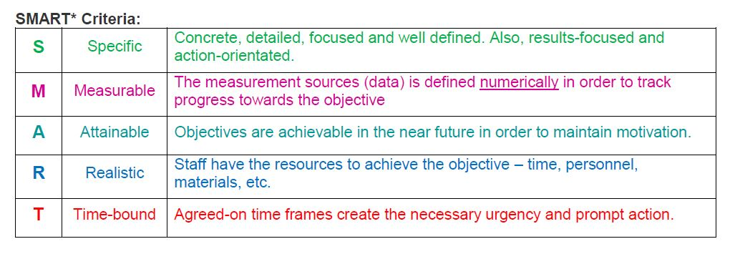

Identified School-wide Expectation OR Specific Location: Respect and Responsibility

|  |  |
| --- | --- |
| **4 Step Problem Solving Process** | **Plan Details** |
| 1. **Problem Identification:** Review your behavior data to identify one school-wide problem. What problem did you identify? *(use numerical data)*   *Note: Identified problem should be based upon data, such as ODRs.*  *(Office Discipline Referral, ODR)* | **Data used:** Referrals by incident.  **Problem Identification Statement:** Based on the data, there are student 36 referrals for Disobedience/Insubordination. |
| **2**. **Problem Analysis:** Why do you think this problem is occurring?  What is your goal? *(use a SMART goal statement with numerical data)* | **Hypothesis:** Students are having a difficult time showing respect to teachers, staff, and classmates and following directions.  **SMART Goal Statement:** All classrooms will work to decrease the number of referrals by 10% each month. Students will display respect towards others. |
| **3. Intervention Design:**  Describehow you will implement a positive reward program/system to decrease this problem. | **Type of Program/System: Economic simulation system**  **Description of Program/System:** Students practice STAR character traits throughout school. If they follow expectations, they will receive Titan Bucks, Class Stars and Cafeteria Cash. The behavioral expectations are discussed and shared with the students on a daily basis in the classroom. The behavioral expectations are shared with students at quarterly behavioral assemblies and class visits. |
| **4. Evaluation:**  A. Implementation fidelity | **How will you monitor the fidelity (consistency and effectiveness) of the staff’s implementation of the reward program/system?** *(2-3 sentences)*  1. Administration will conduct walkthroughs.  2. Grade chair will share monthly reports from their teams.  3. Administration will pull referral report and present class stars accordingly. |
| B. Student outcome monitoring *(use numerical data)* | **How will you know if the reward program/system is positively impacting students? What measurable data will you use to determine “success”?**  If student referrals decrease each month and students visiting store increases as well as stars and cafeteria cash, then we will know the reward program in positively impacting students. |

|  |
| --- |
| **CRITICAL ELEMENT #6: Effective Discipline Procedures: You can choose to use the flow chart below or create your own** |

This flow chart is posted in all classrooms and used to teach students during behavior lessons.

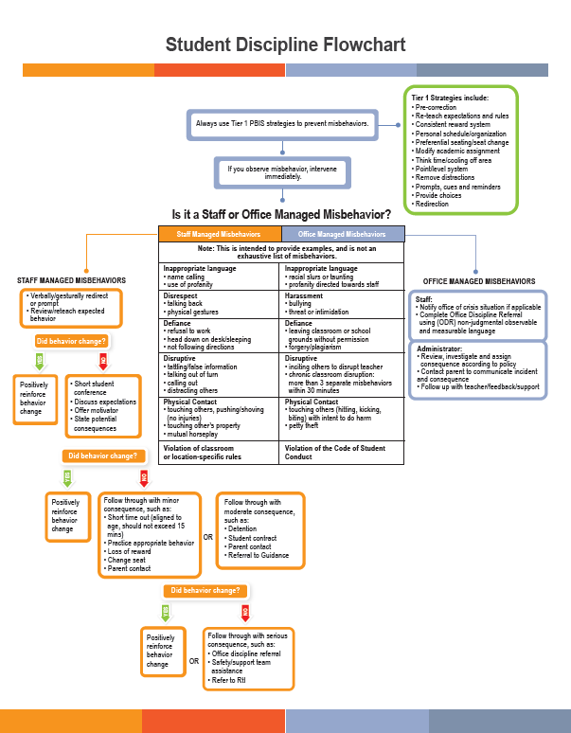

|  |
| --- |
| **CRITICAL ELEMENT # 7: Classroom Management Systems** |

**7A.** Evidence-based Tier 1 classroom management system:

|  |  |
| --- | --- |
| Which evidence-based system(s) are you using? | Provide 2-3 action steps the team will take to help educators improve their classroom management system. |
| CHAMPS  Positive Behavior Interventions and Supports and the Classroom  [https://fl-pda.org/#/category/26](https://fl-pda.org/" \l "/category/26)  Other: Click here to enter name of system. | 1. The PBIS Team will conduct behavioral assemblies to set expectations for students.  2. The teachers will receive training on strategies to use with students comprehensive of Tier 1-3 strategies. |

**7B.** The administration reviews and analyzes the fidelity of staff implementation of Tier 1 classroom management systems ***across teachers*** using:

|  |
| --- |
| CHAMPs 7 Up Checklist [Icon  Description automatically generated](https://browardschools.instructure.com/courses/1193624/files/198522839?wrap=1) |
| Classroom Snapshot (Classroom Management Assessment) [Icon  Description automatically generated](https://browardschools.instructure.com/courses/1193624/files/folder/Documents?preview=199648840) |
| PBIS Classroom Assistance Tool (CAT) |
| Other *(specify):* |

**7C**. Percentage of classroom referrals: ***Use 2021-2022 school year behavior data***

|  |  |
| --- | --- |
| Total number of discipline referrals **from classrooms**: | 77 |
| Total number of *other* **school-wide** discipline referrals (not including classrooms): | 30 |
| % of referrals in the classroom: | 72% |
| Do more than 40% of your referrals come from the classroom? | Yes  No |

***If >40% of discipline referrals come from the classroom, it suggests Tier 1 classroom management implementation may need to be strengthened school wide.***

|  |
| --- |
| If “**Yes**”, school-wide classroom management professional development will be conducted: |
| District iCHAMPS Training If “Other”, indicated system here: Click here to enter text. |

|  |
| --- |
| **CRITICAL ELEMENT # 8: Data Collection and Analysis** |

**8A.** Core Effectiveness: ***Use 2021-2022 school year behavior data***

|  |  |  |  |  |
| --- | --- | --- | --- | --- |
| TOTAL Population: | 735 | % of Total Population | Core Effectiveness | |
| # Referrals: | # of Students: |
| 1. 0 - 1 referrals | 38 | 96% | Are your 0 – 1 referral > 80%? | Yes No |
| II. 2 - 5 referrals  (at risk students) | 24 | 3% | Are your 2 - 5 referrals <15%? | Yes No |
| III. > 5 referrals  (high-risk students) | 6 | 1% | Are your >5 referrals <5%? | Yes No |

**8B.** Core Effectiveness Action Steps:

|  |  |
| --- | --- |
| If you answered “Yes” to I, II, and III above, then your core is effective.  Based upon table 8A, is your core effective? | Yes No |
| Answer **either** (a) or (b):  (a) If your core is effective, then identify action steps your school leadership team should continue to take for early identification of at risk or high-risk students.  (b) If you answered “No” to at least one of the items above (I, II, or III) then indicate the supports and interventions and action steps your school leadership team will implement *at the* *beginning* of the next school year to improve core strength: | |
| Core Effectiveness Action Steps: *(2-4 steps)*  1. The school will ensure that the guidance counselor, the classroom teacher, and administration monitor all students that received more than 3 referrals, starting at the beginning of the year.  2. A conference will be held with the student and parents.  3. A success plan will be developed for the student. | |

**8C.** Disproportionality is often measured with the relative risk statistic calculation (Relative Risk Ratio = RRR), a measure that indicates the probability of a certain event (e.g., suspensions) for one subgroup when compared to all other subgroups.

[](https://browardschools.instructure.com/courses/1193624/files/folder/Documents?preview=199645018)Please refer to and review the Relative Risk Ratio template in Critical Element #8 on the SPBP CANVAS Resource Page. Download and save the template to calculate and identify your school’s RRR relative to disproportionality among subgroups for behavioral referrals.

|  |  |
| --- | --- |
| If your RRR is greater than 1.0 for any subgroup, disproportionality is indicated for that subgroup. Is disproportionality shown in any of your subgroups? | Yes No |
| **“Yes”** indicates that action steps are needed for that specific subgroup. Your school leadership team should collaborate with your school’s Equity Liaison (EL) to identify the root cause of disparity and create a discipline goal with actionable steps to decrease subgroup disproportionality. Schools with an RRR ≥ 3.0 are significantly disproportionate. Use the root cause template provided to help you problem solve. | |

|  |
| --- |
| **Critical Elements # 9: SPBP Implementation Planning** |

The SPBP Implementation Plan guides the PBIS team in the development and execution of evidence-based practices.

The PBIS team reviews and updates the plan quarterly to ensure fidelity of implementation.

Please refer to and review the SPBP Implementation Plan template in Critical Element #9 of the SPBP CANVAS Resource Page. Download and share the plan with your PBIS team members. Use the plan in your quarterly PBIS meetings.

|  |  |
| --- | --- |
| **“Yes”** indicates that the school administration and the PBIS team have reviewed the SPBP Implementation Plan and that it will be updated quarterly. | Yes No |

|  |
| --- |
| **CRITICAL ELEMENT # 10: Evaluation** |

**10A. Staff** Implementationof the School-wide Positive Behavior Plan: review goals, evaluate implementation, and create 2 action steps to review in quarterly PBIS meetings.

*“Are* ***staff*** *implementing the SPBP with fidelity? If not, how will you address this area?”*

|  |  |  |
| --- | --- | --- |
| Staff Implementation Goal | Quarterly Team Review:  Implemented with fidelity? | If you answered **No**, enter 2 action steps your school will take to move towards this goal by the next PBIS meeting. |
| 100% of hallways, front office, cafeteria, and other public areas all have school-wide expectations and location-specific rules posted | Yes No | By Click here to enter a date ,  1.  2. |
| 100% of instructional staff has delivered expectations and rules lesson plans as written and when indicated. | Yes No | By Click here to enter a date ,  1.  2. |
| 100% staff members are oriented to the Discipline Flow Chart. It is used consistently by 100% instructional staff, behavioral support, and administrators. | Yes No | By Click here to enter a date ,  1.  2. |
| A reward system is implemented by 100% staff for *all* students. | Yes No | By Click here to enter a date ,  1.  2. |

**10B.** The SPBP is successful in positively impacting **students:** review 2021-2022 behavior data and create SMART goals. Evaluate implementation and create action steps to review in quarterly PBIS meeting.

*“If staff are implementing the SPBP consistently and effectively, is it positively impacting* ***students****? How will you know?”*

|  |  |  |
| --- | --- | --- |
| **STUDENT Outcome Monitoring** | | |
| Student Outcome Data | Complete the SMART goal to determine “successful” student outcomes *(use numerical data)* | List 2 action steps your team will take to ensure this goal is monitored and meets or exceeds the SMART goal. |
| **Behavior Incidents**  (See critical element #3A) | By 5/26/2023, Disobedience/Insubordination will indicate a 2% decrease as measured by ODRs in BASIS. | 1. Monitor for use of behavioral rewards system.  2. Maintain parent communication. |
| **Top 3 event locations**  (See critical element #4A) | By 5/26/2023 , the frequency of behavioral incidents in one top 3 location, Classroomwill decrease by 2% as measured by ODRs in BASIS | 1. Champs and Classroom management plans will be implemented and monitored.  2. School and classroom recognition and rewards will continue. |
| **Core effectiveness**  (See critical element #8A) | By 5/26/2023, the Core Effectiveness (students with 0-1 referrals) will increase 2% as evidenced by ODRs in BASIS. | 1. Champs and Classroom management plans will be implemented and monitored.  2. School and classroom recognition and rewards will continue. |
| **Classroom referrals**  (See critical element #7C) | By 5/26/2023 classroom referrals will decrease by 2 % as evidenced by ODRs in BASIS. | 1. Champs and Classroom management plans will be implemented and monitored.  2. School and classroom recognition and rewards will continue. |

|  |
| --- |
| **SPBP Submission** |
| 1. Upload completed SPBP into OneDrive 2. Complete SPBP Submission Survey |